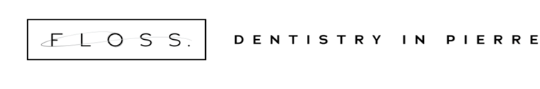
Nicholas Renemans, DDS 603 E Sioux Ave
Chelsey Roberts Renemans, DDS Pierre, SD 57501 FlossDDS.com (605) 224-2161

Patient Information
First Name____________________ Last Name_________________________ Middle Initial______
Preferred Name_______________ Birth Date________________ Age_______ Sex: Male Female
Mailing Address_________________________City/State/Zip_________________________________
Home Phone________________ Work Phone__________________ Cell_______________________
Email Address______________________________ Text and Email Notifications: Yes/No
Social Security #_____________ Marital Status: Married___ Single___ Divorced___ Widowed___
Employment Status: Full Time_____ Part Time_____ Retired____ Employer______________________
Emergency Contact_________________________ Phone____________________________________
Dental Insurance: Yes No ID#____________________ Medicaid: Yes No ID#________________
Subscriber DOB:______________________ Subscriber SS#:________________________________
Subscriber Employer:______________________________________________

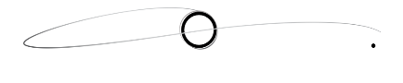

Responsible Party
First Name____________________ Last Name_________________________ Middle Initial______
Relationship to Patient________________________________________________________________
Home Address______________________ City/State/Zip_____________________________________
Mailing Address_____________________ City/State/Zip_____________________________________
Home Phone___________________ Work Phone_______________ Cell_______________________
Social Security #___________________________ Birth Date___________________
Employment Status: Full Time_____ Part Time_____ Retired____ Employer______________________

Preferred Dentist________________________ Preferred Hygienist___________________________
Dental Information

Preferred Pharmacy______________________ Previous Dentist______________________________
When was your last dental visit? __________________
Do you have any dental concerns? _______________________________________________________
Whom may we thank for referring you to our office? ________________________________________

Medical History
Please list serious illness(es) or medical conditions:
_____________________________________________________________________________________
Have you been hospitalized or had a major operation in the last year?____________________________
Are you taking any medications, pills, or drugs? Yes No
List all medications____________________________________________________________________
____________________________________________________________________________________
Have you taken any Osteoporosis medications? Yes No If yes, list medication____________________
Do you have a medical condition requiring antibiotic premedication prior to dental treatment? Yes No
(i.e. Prosthetic Heart Valve, Endocarditis, Artificial Joint Replacement)
If yes, explain condition__________________________________________________________________
Do you use tobacco? Yes No If yes, list tobacco source:______________________________________
Women: Are you pregnant? Yes No Nursing? Yes No
Allergies: Penicillin: Yes No Codeine: Yes No Latex: Yes No
Other________________________________________________________________________________

Do you have, or have you had any of the following?
Yes No Alzheimer’s Disease Yes No Mitral Valve Prolapse
Yes No Congenital Heart Disorder
Yes No High Blood Pressure
Yes No High Cholesterol Yes No Heart attack/Failure
Yes No Angina Yes No Heart Murmur
Yes No Blood Thinner Yes No Heart Pacemaker
Yes No Blood Disease Yes No Asthma
Yes No Hepatitis A, B or C Yes No Cold Sores
Yes No Herpes Yes No Cancer
Yes No Chemotherapy Yes No Radiation treatments
Yes No Tumors/Growths
Yes No Frequent Cough
Yes No Anaphylaxis
Yes No Tuberculosis
Yes No Cortisone Medicine Yes No Pain in Jaw Joints
Yes No Diabetes Yes No Psychiatric Care
Yes No Drug Addiction Yes No Frequent Headaches
Yes No Epilepsy/Seizures Yes No Stroke
Yes No Excessive Bleeding Yes No Fainting Spells/Dizziness
Yes No AIDS/HIV Positive

Are there any other concerns you would like us to know?_________________________________________________________________________________________________________________________________________________________________________________

To the best of my knowledge, the questions on this form have been accurately answered. I understand that providing incorrect information can be dangerous to my (or patient’s) health. It is my responsibility to inform the dental office of any changes in medial status.

Signature of Patient, Parent or Guardian______________________________________ Date__________

